**1585959** – order no tI - amp

**Unity gain amplifier**

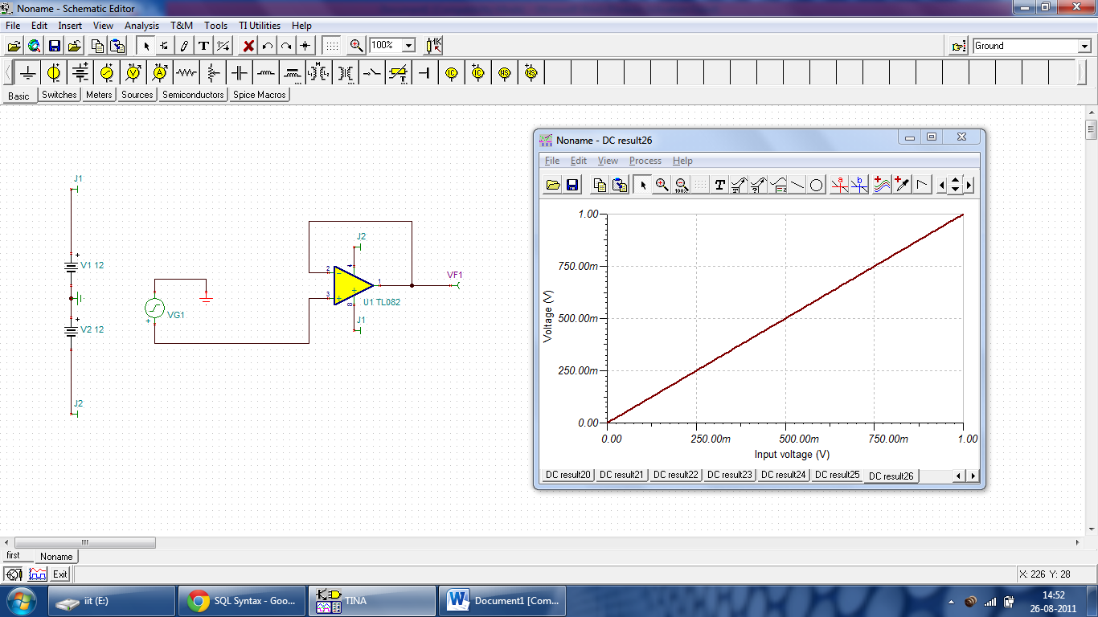

With a resistor

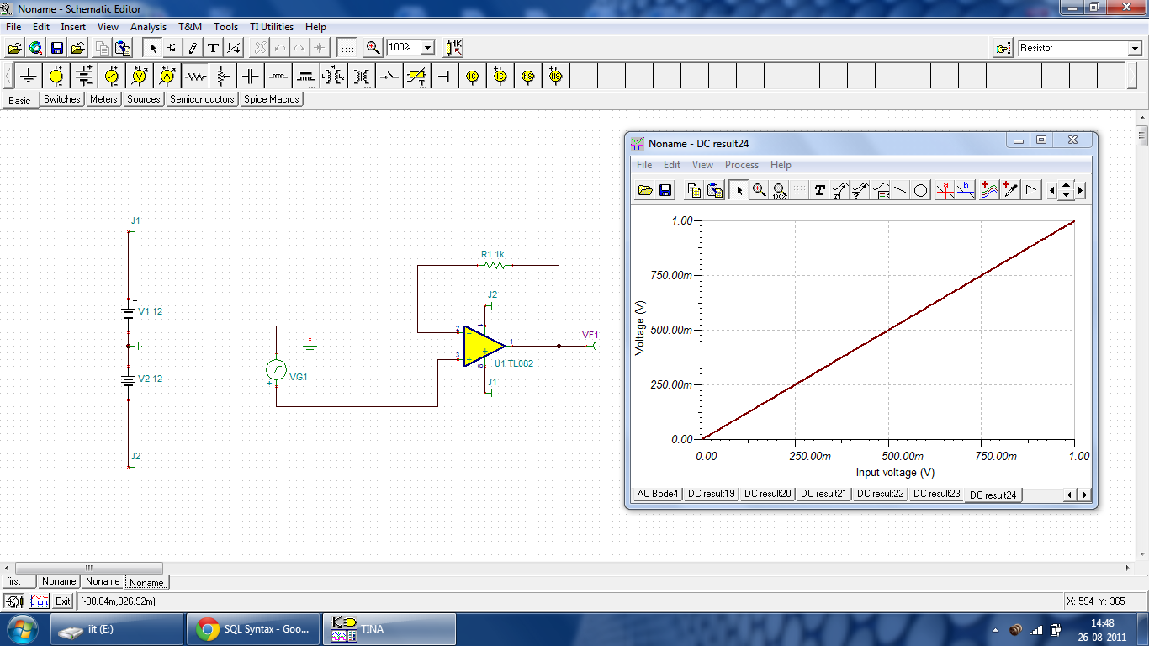

**Open loop amplifier**

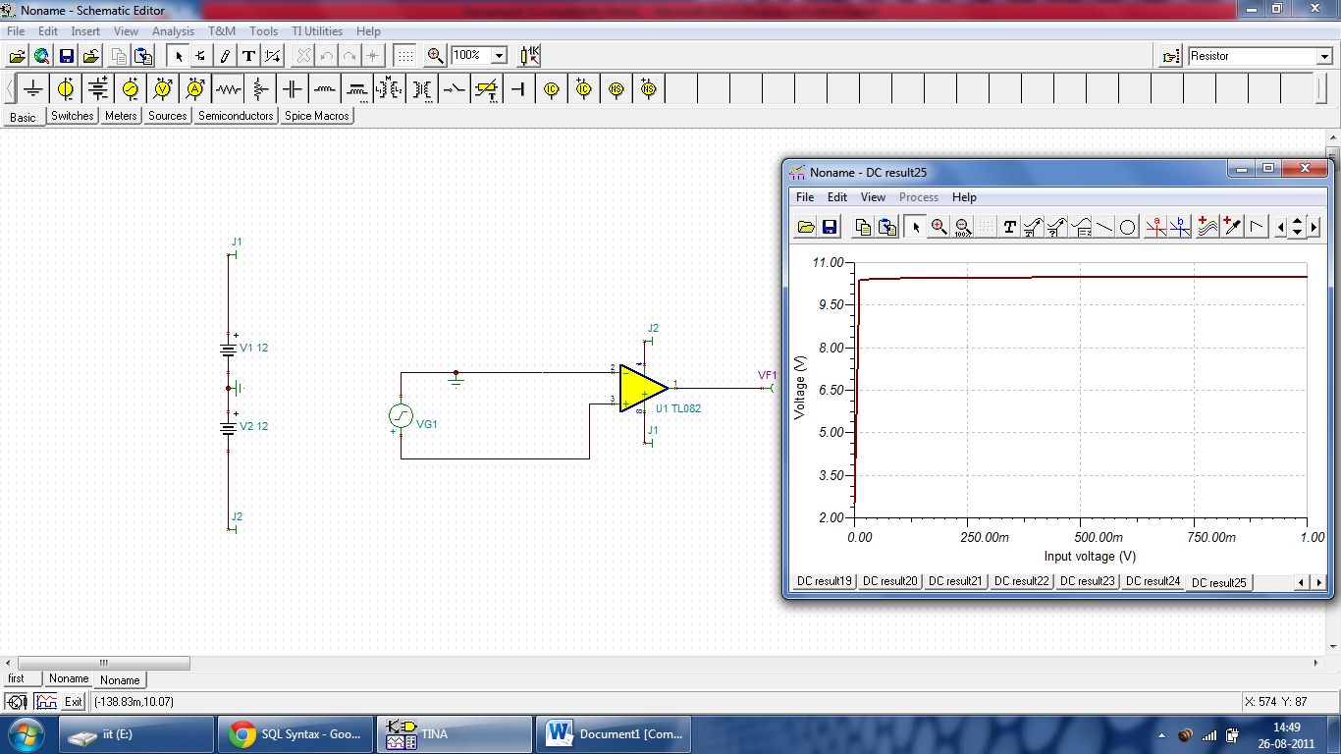

Gain two – non inverting

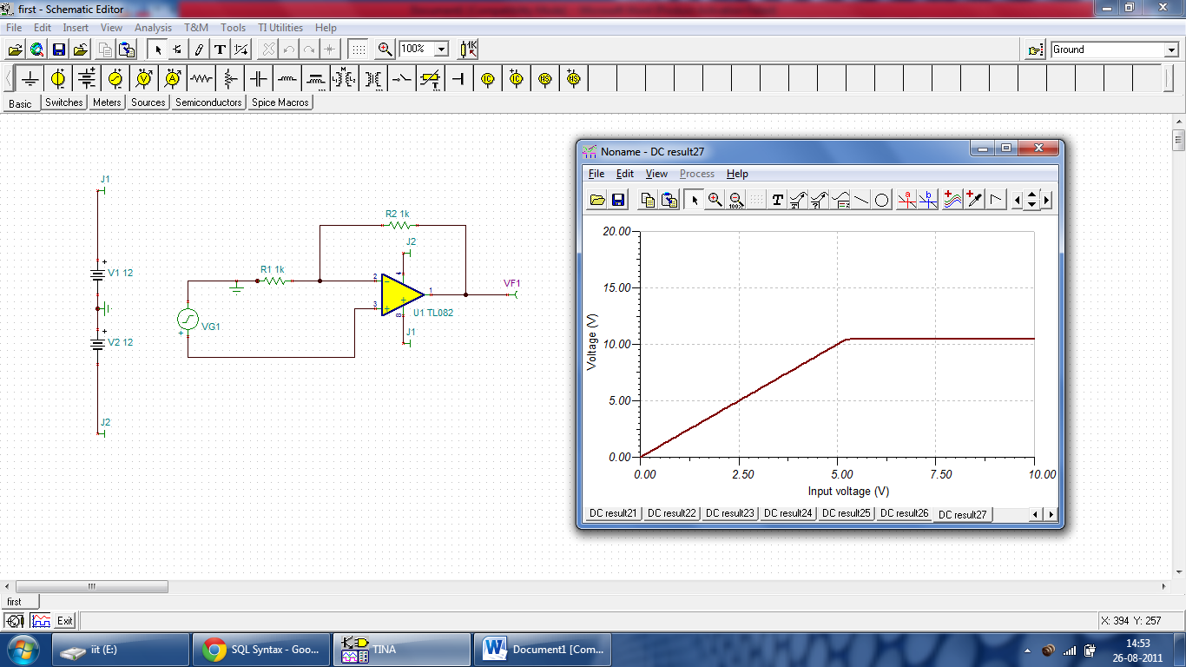

Gain two – inverting